

Evaluation Report

Personal contribution and importance of interpersonal skills.



January 1, 2019

K.P.I. Shenesh perera

IDM

# Evaluation Report

Confession: I worked individually for the parts that were meant to be done as a group, as such the sole contribution to the first 2 tasks were entirely mine. This was not something I decided because I lack teamwork functionality, it was because there were no individuals in my batch of colleagues that were doing this assignment. Therefore, I will describe how I broke down and performed the tasks.

The effectiveness and application of interpersonal skills during the design and delivery process

## Interpersonal Skills during design processes

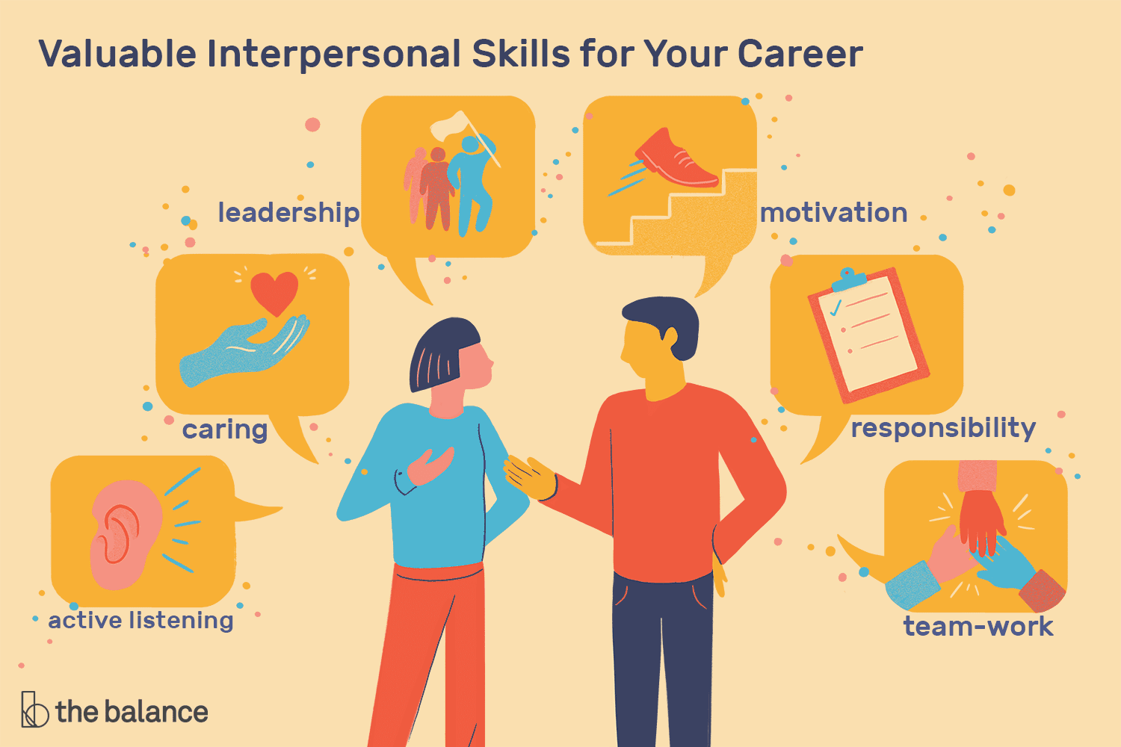

Figure 1.0, thebalancecareers.com, Alison Doyle, January 30, 2019

In order to evaluate a particular scenario and turn it into a product, a lifecycle must be followed. This lifecycle includes a design stage where we visualize, set goals and milestones, analyze and understand the problem we are to tackle and identify what type of product the scenario expects.

The design process is the initial stage of any life cycle, therefore must be executed in utmost clarity. While working in a team, interpersonal skills rather communication and gesture patterns lead to faster and more concise work flow.

Interpersonal skills include communication skills, setting social standards, analysis through listening and measuring a person’s strengths and weakness through speech and question.

In order to maximize the consensus of these traits, one must remain calm and maintain a very rational and logical mindset.

During the design process, an individual with good interpersonal skills is to identify weak and strong members, gauge the among out of quality work they can output, how task-oriented a person is and those who boast an aura of creativity around them.

A good leader is a good communicator, and therefore not only maintains but also executes high standard interpersonal skills during design processes.

In my design stage of the project, I used Microsoft Project 2019, I produced a Gantt chart and a timeline. Now the Gantt chart is for those who I thought would want to have a clear consensus of the project and a timeline for those who have difficulty processing large amounts of information.

This is an effective demonstration of interpersonal skills, because I understood that among the intended audience there will not only be the those who are capable of analyzing situations and processing large volumes of information but also those who would have difficulties understanding and visualizing things.

Those who refer the timeline after grabbing a general idea can refer to the Gantt chart and get a full idea of the process.

This means that those who are weak and those who are strong both end up winning due to the choice of my design that was executed due to the quality in my interpersonal skills. Although this may seem a sort of indirect or minor implication of interpersonal skills, this served a very large benefit.

## Interpersonal skills during delivery processes

The delivery process is the final stage of almost any lifecycle, during this process all difficult tasks of execution have been completed and a product has been created as such the delivery stage is the time when the team responsible for the project should “sell” their product, by that it could be said that this is the time where interpersonal communication, negotiation and crowd manipulation techniques are extremely important.

No matter how perfect a product is, no matter how foolproof a product is and no matter how perfect the product matches the scenario if the team doesn’t delegate and demonstrate how great of a product it actually is, then there is no chance for that product to be delivered because there will be no convinced audience willing to buy it, even if there existed a premade audience if proper demonstration and explanations aren’t done then the audience will not be satisfied with the product.

As such in order to effectively complete the delivery stage of the lifecycle, those members within a team that boast communication oriented interpersonal skills become necessary.

In my project during the initial stage of preparing my workshop and training package I had to make a decision whether or not to include large volumes of information in them.

I came to the conclusion that there is no point in doing so, as such the workshop only has the most important parts of information written in text form, the rest have been presented as videos or beautiful graphics.

In the training package, instead of flooding it with long seminars and workshops I instead included more activities.

The reason I came to this conclusion is because learning about application and how to apply learned concepts is better than listening to a large amount of unknown information and going home without understanding barely 40% and coming to work the following day the same person 3 days ago.

I wanted my audience to not only understand how important team work and team dynamics are, but also give them a reason to strive to be a better team player, which was shown beautifully through fun activities.

I believe that the audience is now more familiar with each other, that all bridges that had to be crossed were crossed and now they are ready and motivated to work as a team, why? Because they know now that is fun to work as a team. I gave them a reason to work as a team than alone.

This demonstrates one of the most complex applications of interpersonal skills during delivery stages, crowd manipulation or in simpler terms winning the heart of people. Through my workshops, seminars and training package I won the hearts of the people so I could deliver my product to them in a way they will enjoy it and definitely would want more if I was granted the opportunity to.

So by that my product is sold, my audience is happy and I grew as a person. All as a result of knowing how to apply interpersonal skills effectively to comprehend, communicate and manipulate people which is the core of any interpersonal skill.